**EXERCISE 7-PACKAGES**

**SCENARIO 1: CustomerManagement Package**

**PACKAGE SPECIFICATION:**

CREATE OR REPLACE PACKAGE CustomerManagement AS

PROCEDURE AddCustomer (

p_custid NUMBER,

p_name VARCHAR2,

p_dob DATE,

p_balance NUMBER

);

PROCEDURE UpdateCustomer (

p_custid NUMBER,

p_name VARCHAR2,

p_balance NUMBER

);

FUNCTION GetCustomerBalance (

p_custid NUMBER

) RETURN NUMBER;

END CustomerManagement;

/

**PACKAGE BODY:**

CREATE OR REPLACE PACKAGE BODY CustomerManagement AS

PROCEDURE AddCustomer (

p_custid NUMBER,

p_name VARCHAR2,

p_dob DATE,

p_balance NUMBER

) IS

BEGIN

INSERT INTO Customers (CustomerID, Name, DOB, Balance, LastModified)

VALUES (p_custid, p_name, p_dob, p_balance, SYSDATE);

COMMIT;

DBMS_OUTPUT.PUT_LINE('Customer added successfully.');

EXCEPTION

WHEN DUP_VAL_ON_INDEX THEN

DBMS_OUTPUT.PUT_LINE('Error: Customer ID already exists.');

END;

PROCEDURE UpdateCustomer (

p_custid NUMBER,

p_name VARCHAR2,

p_balance NUMBER

) IS

BEGIN

UPDATE Customers

SET Name = p_name,

Balance = p_balance,

LastModified = SYSDATE

WHERE CustomerID = p_custid;

COMMIT;

DBMS_OUTPUT.PUT_LINE('Customer updated successfully.');

END;

FUNCTION GetCustomerBalance (

p_custid NUMBER

) RETURN NUMBER IS

v_balance NUMBER;

BEGIN

SELECT Balance INTO v_balance

FROM Customers

WHERE CustomerID = p_custid;

RETURN v_balance;

EXCEPTION

WHEN NO_DATA_FOUND THEN

RETURN NULL;

END;

END CustomerManagement;

/

**OUTPUT:**

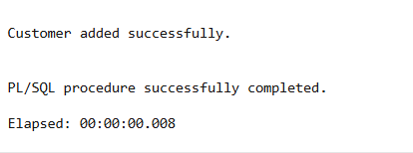

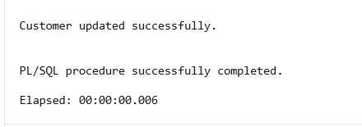

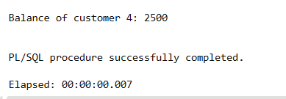

**SCENARIO 2:** **EmployeeManagement Package**

**PACKAGE SPECIFICATION:**

CREATE OR REPLACE PACKAGE EmployeeManagement AS

PROCEDURE HireEmployee (

p_empid NUMBER,

p_name VARCHAR2,

p_position VARCHAR2,

p_salary NUMBER,

p_department VARCHAR2

);

PROCEDURE UpdateEmployee (

p_empid NUMBER,

p_salary NUMBER

);

FUNCTION AnnualSalary (

p_empid NUMBER

) RETURN NUMBER;

END EmployeeManagement;

/

**PACKAGE BODY:**

CREATE OR REPLACE PACKAGE BODY EmployeeManagement AS

PROCEDURE HireEmployee (

p_empid NUMBER,

p_name VARCHAR2,

p_position VARCHAR2,

p_salary NUMBER,

p_department VARCHAR2

) IS

BEGIN

INSERT INTO Employees (EmployeeID, Name, Position, Salary, Department, HireDate)

VALUES (p_empid, p_name, p_position, p_salary, p_department, SYSDATE);

COMMIT;

DBMS_OUTPUT.PUT_LINE('Employee hired successfully.');

EXCEPTION

WHEN DUP_VAL_ON_INDEX THEN

DBMS_OUTPUT.PUT_LINE('Error: Employee ID already exists.');

END;

PROCEDURE UpdateEmployee (

p_empid NUMBER,

p_salary NUMBER

) IS

BEGIN

UPDATE Employees

SET Salary = p_salary

WHERE EmployeeID = p_empid;

COMMIT;

DBMS_OUTPUT.PUT_LINE('Employee salary updated.');

END;

FUNCTION AnnualSalary (

p_empid NUMBER

) RETURN NUMBER IS

v_salary NUMBER;

BEGIN

SELECT Salary INTO v_salary

FROM Employees

WHERE EmployeeID = p_empid;

RETURN v_salary * 12;

EXCEPTION

WHEN NO_DATA_FOUND THEN

RETURN NULL;

END;

END EmployeeManagement;

/

**OUTPUT:**

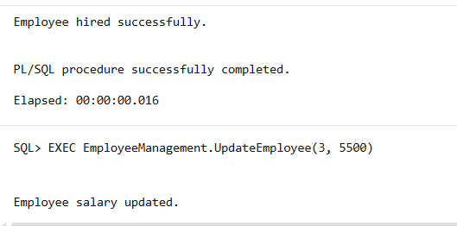

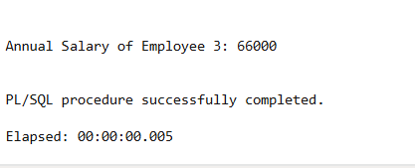

**SCENARIO 3:** **AccountOperations Package**

**PACKAGE SPECIFICATION:**

CREATE OR REPLACE PACKAGE AccountOperations AS

PROCEDURE OpenAccount (

p_accid NUMBER,

p_custid NUMBER,

p_type VARCHAR2,

p_balance NUMBER

);

PROCEDURE CloseAccount (

p_accid NUMBER

);

FUNCTION TotalBalance (

p_custid NUMBER

) RETURN NUMBER;

END AccountOperations;

/

**PACKAGE BODY:**

CREATE OR REPLACE PACKAGE BODY AccountOperations AS

PROCEDURE OpenAccount (

p_accid NUMBER,

p_custid NUMBER,

p_type VARCHAR2,

p_balance NUMBER

) IS

BEGIN

INSERT INTO Accounts (AccountID, CustomerID, AccountType, Balance, LastModified)

VALUES (p_accid, p_custid, p_type, p_balance, SYSDATE);

COMMIT;

DBMS_OUTPUT.PUT_LINE('Account opened successfully.');

END;

PROCEDURE CloseAccount (

p_accid NUMBER

) IS

BEGIN

DELETE FROM Accounts

WHERE AccountID = p_accid;

COMMIT;

DBMS_OUTPUT.PUT_LINE('Account closed successfully.');

END;

FUNCTION TotalBalance (

p_custid NUMBER

) RETURN NUMBER IS

v_total NUMBER;

BEGIN

SELECT SUM(Balance) INTO v_total

FROM Accounts

WHERE CustomerID = p_custid;

RETURN v_total;

EXCEPTION

WHEN NO_DATA_FOUND THEN

RETURN 0;

END;

END AccountOperations;

/

**OUTPUT:**

